**AN IMPROVED ENERGY-EFFICIENT CLUSTERING PROTOCOL**

**TO PROLONG THE LIFETIME OF THE WSN-BASED IOT**

**CHAPTER -1**

**ABSTRACT**

The Internet of Things relies heavily on wireless sensor networks (WSNs) (IoT). However, the energy resources of sensor nodes in a WSN-based IoT network are restricted. By grouping nodes into clusters to reduce the transmission distance between sensor nodes and base stations, a clustering protocol offers an effective method for ensuring node energy savings and extending network lifespan (BS). Current clustering protocols, on the other hand, have problems with the clustering mechanism, which has a negative impact on their efficiency. We suggest an enhanced energy-efficient clustering protocol (IEECP) in this paper to extend the lifespan of WSN-based IoT devices. The proposed IEECP is divided into three parts. For the overlapping balanced clusters, an optimum number of clusters is first calculated. The balanced-static clusters are then developed using a tweaked fuzzy C-means algorithm in combination with a mechanism to minimise and balance the sensor nodes' energy consumption. Finally, cluster heads (CHs) are chosen in optimal locations by rotating the CH function among cluster members using a new CH selection-rotation algorithm that combines a back-off timer mechanism for CH selection and a rotation mechanism for CH rotation. The suggested protocol, in particular, eliminates and balances energy consumption.

The proposed protocol, in particular, reduces and balances node energy usage by optimising clustering structure, and IEECP is ideal for networks with a long lifespan. The findings of the assessment show that the IEECP outperforms current protocols.

Keywords: Wireless sensor network, Internet of Things, clustering protocol, energy consumption, network lifetime.

**CHAPTER-2**

**INTRODUCTION**

With the popularity of laptops, cell phones, PDAs, GPS devices, RFID, and intelligent electronics in the post-PC era, computing devices have become cheaper, more mobile, more distributed, and more pervasive in daily life. It is now possible to construct, from commercial off-the-shelf (COTS) components, a wallet size embedded system with the equivalent capability of a 90’s PC. Such embedded systems can be supported with scaled down Windows or Linux operating systems. From this perspective, the emergence of wireless sensor networks (WSNs) is essentially the latest trend of Moore’s Law toward the miniaturization and ubiquity of computing devices. Typically, a wireless sensor node (or simply sensor node) consists of sensing, computing, communication, actuation, and power components. These components are integrated on a single or multiple boards, and packaged in a few cubic inches. With state-of-the-art, low-power circuit and networking technologies, a sensor node powered by 2 AA batteries can last for up to three years with a 1% low duty cycle working mode. A WSN usually consists of tens to thousands of such nodes that communicate through wireless channels for information sharing and cooperative processing. WSNs can be deployed on a global scale for environmental monitoring and habitat study, over a battle field for military surveillance and reconnaissance, in emergent environments for search and rescue, in factories for condition based maintenance, in buildings for infrastructure health monitoring, in homes to realize smart homes, or even in bodies for patient monitoring After the initial deployment (typically ad hoc), sensor nodes are responsible for self-organizing an appropriate network infrastructure, often with multi-hop connections between sensor nodes.

The on board sensors then start collecting acoustic, seismic, infrared or magnetic information about the environment, using either continuous or event driven working modes. Location and positioning information can also be obtained through the global positioning system (GPS) or local positioning algorithms. This information can be gathered from across the network and appropriately processed to construct a global view of the monitoring phenomena or objects. The basic philosophy behind WSNs is that, while the capability of each individual sensor node is limited, the aggregate power of the entire network is sufficient for the required mission. In a typical scenario, users can retrieve information of interest from a WSN by injecting queries and gathering results from the so-called base stations (or sink nodes), which behave as an interface between users and the network. In this way, WSNs can be considered as a distributed database .It is also envisioned that sensor networks will ultimately be connected to the Internet, through which global information sharing becomes feasible.

The era of WSNs is highly anticipated in the near future. In September 1999, WSNs were identified by Business Week as one of the most important and impactive technologies for the 21st century Also, in January 2003, the MIT’s Technology Review stated that WSNs are one of the top ten emerging technologies .It is also estimated that WSNs generated less than $150 million in sales in 2004, but would top $7 billion by 2010 [133]. In December 2004, a WSN with more than 1000 nodes was launched in Florida by the ExScal team ,which is the largest deployed WSN to date.

The term wireless is normally used to refer to any type of electrical operation which is accomplished without the use of a "hard wired" connection. Wireless communication” is the transfer of information over a distance without the use of electrical conductors or "wires“ using some form of energy, e.g. radio frequency (RF), infrared light (IR), laser light, visible light, acoustic energy. A sensor is a device that measures a physical quantity and converts it into a signal which can be read by an observer or by an instrument, e.g. thermocouple, strain gauge. In general, the term network can refer to any interconnected group or system. A network is any method of sharing information between two systems.

Latest technological advancement in the field of hardware has developed small size, low capacity sensors with limited embedded on board processing unit that is able to communicate wirelessly. However, a lot of sensor networks also obviously introduce an enormous amount of data in WSNs (wireless sensor networks), that can process receive and transmit signals/data [1]. When various sensor nodes that are independent to each other are employed inside the targeted area or in its vicinity, it is referred to as sensor network [2]. A WSN is a self-organizing network which is designed using spatially distributed and is used sensors for monitoring physical environmental. Since WSN is usually dynamic in nature, its topology will change frequently. This will cause adding a new node into the network due to loss of connectivity. In past, there were many conventional centralized algorithms which require knowing whole knowledge of the overall network and also needing to update the information of entire network. In order to avoid serious protocol failure, it is required to have error free transmission or critical node free of failure [3]. In order to avoid the failure caused by single node, clustering algorithms are used, as they execute locally within partial nodes.

Wireless Sensor Networks (WSNs) can be defined as a self-configured and infrastructure-less wireless networks to monitor physical or environmental conditions, such as temperature, sound, vibration, pressure, motion or pollutants and to cooperatively pass their data through the network to a main location or sink where the data can be observed and analysed. A sink or base station acts like an interface between users and the network. One can retrieve required information from the network by injecting queries and gathering results from the sink. Typically a wireless sensor network contains hundreds of thousands of sensor nodes. The sensor nodes can communicate among themselves using radio signals. A wireless sensor node is equipped with sensing and computing devices, radio transceivers and power components. The individual nodes in a wireless sensor network (WSN) are inherently resource constrained: they have limited processing speed, storage capacity, and communication bandwidth. After the sensor nodes are deployed, they are responsible for self-organizing an appropriate network infrastructure often with multi-hop communication with them. Then the onboard sensors start collecting information of interest. Wireless sensor devices also respond to queries sent from a “control site” to perform specific instructions or provide sensing samples. The working mode of the sensor nodes may be either continuous or event driven. Global Positioning System (GPS) and local positioning algorithms can be used to obtain location and positioning information. Wireless sensor devices can be equipped with actuators to “act” upon certain conditions.

Wireless sensor networks (WSNs) enable new applications and require non-conventional paradigms for protocol design due to several constraints. Owing to the requirement for low device complexity together with low energy consumption (i.e. long network lifetime), a proper balance between communication and signal/data processing capabilities must be found. This motivates a huge effort in research activities, standardization process, and industrial investments on this field since the last decade ([Chiara et. al. 2009](https://www.intechopen.com/books/wireless-sensor-networks-technology-and-protocols/overview-of-wireless-sensor-network#B8)). At present time, most of the research on WSNs has concentrated on the design of energy- and computationally efficient algorithms and protocols, and the application domain has been restricted to simple data-oriented monitoring and reporting applications (Labrador et. al. 2009). The authors in ([Chen et al., 2011](https://www.intechopen.com/books/wireless-sensor-networks-technology-and-protocols/overview-of-wireless-sensor-network#B36)) propose a Cable Mode Transition (CMT) algorithm, which determines the minimal number of active sensors to maintain K-coverage of a terrain as well as K-connectivity of the network. Specifically, it allocates periods of inactivity for cable sensors without affecting the coverage and connectivity requirements of the network based only on local information. In (Cheng et al., 2011), a delay-aware data collection network structure for wireless sensor networks is proposed. The objective of the proposed network structure is to minimize delays in the data collection processes of wireless sensor networks which extends the lifetime of the network. In ([Matin et al., 2011](https://www.intechopen.com/books/wireless-sensor-networks-technology-and-protocols/overview-of-wireless-sensor-network" \l "B25)), the authors have considered relay nodes to mitigate the network geometric deficiencies and used Particle Swarm Optimization (PSO) based algorithms to locate the optimal sink location with respect to those relay nodes to overcome the lifetime challenge. Energy efficient communication has also been addressed in ([Paul et al., 2011](https://www.intechopen.com/books/wireless-sensor-networks-technology-and-protocols/overview-of-wireless-sensor-network#B4); [Fabbri et al. 2009](https://www.intechopen.com/books/wireless-sensor-networks-technology-and-protocols/overview-of-wireless-sensor-network" \l "B13)). In ([Paul et al., 2011](https://www.intechopen.com/books/wireless-sensor-networks-technology-and-protocols/overview-of-wireless-sensor-network#B4)), the authors proposed a geometrical solution for locating the optimum sink placement for maximizing the network lifetime. Most of the time, the research on wireless sensor networks have considered homogeneous sensor nodes. But nowadays researchers have focused on heterogeneous sensor networks where the sensor nodes are unlike to each other in terms of their energy. In ([Han et al., 2010](https://www.intechopen.com/books/wireless-sensor-networks-technology-and-protocols/overview-of-wireless-sensor-network#B37)), the authors addresses the problem of deploying relay nodes to provide fault tolerance with higher network connectivity in heterogeneous wireless sensor networks, where sensor nodes possess different transmission radii. New network architectures with heterogeneous devices and the recent advancement in this technology eliminate the current limitations and expand the spectrum of possible applications for WSNs considerably and all these are changing very rapidly.

On comparing with centralized algorithms, clustering algorithms are more robust and scalable. To obtain prolong life of the network, energy efficient protocols are designed according to the characteristics of WSN, by efficiently organizing the sensor nodes in clusters.

CHARACTERISTICS OF WSN:

It was observed that there were many similarly between sensor network and ad hoc networks, both are dynamic and on demand. Some other similar characteristics are mobility, switching and the limit capability of the battery power. WSN also has some distinct properties as listed below

A. Power Efficiency Sensor nodes are often facing problem of void and dumped due to battery power run down of sensor node. In addition, as per many researches the energy consumes by the nodes in sending data over the communication is more than the energy of the nodes in computing. Therefore, maximize wireless sensor network’s lifetime is a problem is exists.

B. Fault Tolerance The wireless sensor nodes have ability of organizing itself in the network as nodes have deployed in random fashion remote location and unreceptive environment. For preventing from fault sensor nodes have worked in collaboration to reorganize itself and used distributed algorithm to form network automatically

C. Mobility of Nodes As it knows that wireless sensor network is collection sensor network in which some nodes are movable and some are static. We say that nature of WSN is dynamic. Due to limited resources nodes can failed for battery fatigue or some other conditions, communication channel may be disrupted. Topology is also affected by adding of node or failure of node. Thus, the WSN nodes have developed the function of self-governing and self-management

D. Heterogeneity of Nodes Heterogeneous means different nature of nodes, which are different from each other by the communication range, mobility, sensing parameters and work at different protocols etc. Heterogeneous WSN are collection of various different types of sensor nodes with have different features, follow different protocol, different computation capacity and different sensing and monitoring range. Deployment of heterogeneous sensor network more typical than homogeneous wireless sensor network

E. Scalability of Node In WSNs sensor nodes are able to collecting, processing, arranging, aggregating and sending data to sink node or base station. As number of nodes increases sensor network become very large. In the large network sensor nodes are able to communicate with faraway nodes but also produce traffic problem, difficult to manage and coordinate

F. Responsiveness WSN has ability to quickly adapt itself the changes in the topology. It has considered its responsiveness. To get highly responsiveness in the network. It needs to compromise with latency of network and as well as scalability

G. Communication Failures Wireless sensor networks work in free style fashion as ad hoc in nature. Sensor device has very low communication bandwidth and low communication distance range. And also it has some mobility degree of freedom. Sensor network will also be affected by the impact of natural disaster such as mountains slid, buildings damage and storms and cyclones, heavy rain falls and thunder lighting, the remote location obstacles, weather, and many more. That’s why; it is very difficult to manage and maintain WSN run smoothly. This is an important impact of research direction in the future

COMPONENTS OF WSN

A. Gateway: Gateways work as system network administrators to interface with node to Personal Computers (PCs) and Personal Digital Assistants (PDAs). Gateway may classify into various states:

1. Active

2. Passive

3. Hybrid Active gateway (sensor node) sends its message asynchronously to the server gateway. Passive gateway has worked in different way from active gateway. First it has sent a request packet to nodes and then has sent its own data. As the name suggest Hybrid gateway works as both active and passive gateway, which can operate in both of the states

B. Sensor/Actuator :

Without sensor we can image wireless sensor network. Sensors device collects data from their surrounding and convert environmental attribute/property just like sound, temperature, color, smoke, light, vibration and many more physical properties etc. into analog signals

C. Sensor Node:

Basically sensor nodes are three types

1. Temperature sensor node

2. Vibration sensor node

3. Moisture Sensor Node

But some other nodes can have more advantage that have taken capture pictures, motion detection, pressure monitor, intensity of light, etc

The sensor nodes are transceivers usually scattered in a sensor field where each of them has the capability to collect data and route data back to the sink/gateway and the end-users by a multi-hop infrastructureless architecture through the sink. They use their processing capabilities to locally carry out simple computations and transmit only the required and partially processed data. The sink may communicate with the task manager/end-user via the Internet or satellite or any type of wireless network (like WiFi, mesh networks, cellular systems, WiMAX, etc.), making Internet of Things possible. However, in many cases the sink can be directly connected to the end-users. Note that there may be multiple sinks/gateways and multiple end-users in the architecture, each sensor node is consisting of five main components; a microcontroller unit, a transceiver unit, a memory unit, a power unit and a sensor unit. Each one of these components is determinant in designing a WSN for deployment. The microcontroller unit is in charge of the different tasks, data processing and the control of the other components in the node. It is the main controller of the wireless sensor node, through which every other component is managed. The controller unit may consist of an on-board memory or may be associated with a small storage unit integrated into the embedded board. It manages the procedures that enable the sensor node to perform sensing operations, run associated algorithms, and collaborate with the other nodes through wireless communication. Through the transceiver unit a sensor node performs its communication with other nodes and other parts of the WSN. It is the most power consumption unit. The memory unit is for temporal storage of the sensed data and can be RAM, ROM and their other memory types (SDRAM, SRAM, EPROM, etc.), flash or even external storage devices such as USB. The power unit, which is one of the critical components, is for node energy supply. Power can be stored in batteries (most common) rechargeable or not or in capacitors. For extra power supply and recharge, there can be used natural sources such as solar power in forms of photovoltaic panels and cells, wind power with turbines, kinetic energy from water, etc. Last but not least is the sensor unit, which is the main component of a wireless sensor node that distinguishes it from any other embedded system with communication capabilities. It may generally include several sensor units, which provide information gathering capabilities from the physical world. Each sensor unit is responsible for gathering information of a certain type, such as temperature, humidity, or light, and is usually composed of two subunits: a sensor and an analog-to-digital converter (ADC). The analog signals produced by the sensor based on the observed phenomenon are converted to digital signals by the ADC, and then fed into the processing unit. In WSNs, the sensor nodes have the dual functionality of being both data originators and data routers. Hence, communication is performed for two reasons: Source function: Each sensor node’s primary role is to gather data from the environment through the various sensors. The data generated from sensing the environment need to be processed and transmitted to nearby sensor nodes for multi-hop delivery to the sink. • Router function: In addition to originating data, each sensor node is responsible for relaying the information transmitted by its neighbours. The low-power communication techniques in WSNs limit the communication range of a node. In a large network, multi-hop communication is required so that nodes relay the information sent by their neighbours to the data collector, i.e., the sink. Accordingly, the sensor node is responsible for receiving the data sent by its neighbours and forwarding these data to one of its neighbours according to the routing decisions. Except for their transmit/receive operation state, transceivers can be put into an idle state (ready to receive, but not doing so) where some functions in hardware can be switched off, reducing energy consumption, a transceiver expends a similar amount of energy for transmitting and receiving, as well as when it is idle. Moreover, a significant amount of energy can be saved by turning off the transceiver to a sleep state whenever the sensor node does not need to transmit or receive any data. In this state, significant parts of the transceiver are switched off and the nodes are not able to immediately receive something. Thus, recovery time and start up energy to leave sleep state can be significant design parameters. When the transmission ranges of the radios of all sensor nodes are large enough and the sensors can transmit their data directly to the centralized base station, they can form a star topology. In this topology, each sensor node communicates directly with the base station using a single hop. However, sensor networks often cover large geographic areas and radio transmission power should be kept at a minimum in order to conserve energy; consequently, multi-hop communication is the more common case for sensor networks .In this mesh topology, sensor nodes must not only capture and disseminate their own data, but also serve as relays for other sensor nodes, that is, they must collaborate to propagate sensor data towards the base station. This routing problem, that is, the task of finding a multi-hop path from a sensor node to the base station, is one of the most important challenges and has received large attention from the research community. When a node serves as a relay for multiple routes, it often has the opportunity to analyze and pre-process sensor data in the network, which can lead to the elimination of redundant information or aggregation of data that may be smaller than the original data.

**ARCHITECTURE OF SENSOR NODE :**

This section discusses major components and other dependants components of wireless sensor network.

A. Main Components 1) Sensing Unit All sensor devices are equipped with sensing units. It is usually are divided into two sub units: sensors part and analog-to-digital. In sensor part which contains cameras, video, sound, and/or scalar sensors and analog-to-digital converters. Analog signals generated by sensor nodes and converted into digital signals with help of software and send to processing unit 2) Power Unit Power unit provides power to sensor node and sensor uses energy for many areas as sensing environment, data processing which come from sensor nodes and communicated to other sensor nodes. From many researches it is found that more energy is consume than any other processes. Basic source of power of sensor node is electrochemical material such as NiMH, NiZn, and lithium ion cells 3) Communication Unit . A communication unit is subsystem, stabilize interface between the device and the network and a make possible transmission and receiver with the help of communication software 4) Processing Unit After getting information or data from sensor nodes/devices then processing unit starts its execution in the system software as coordinating sensing. It is interacted with storage unit and communication tasks.

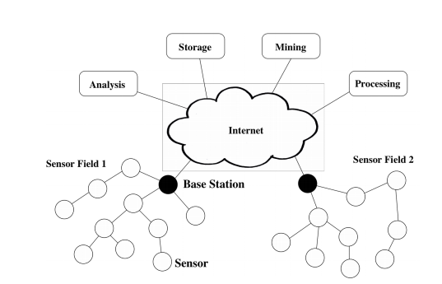

Figure: General System Model of a WSN

WSN Network Topologies:

For radio communication networks, the structure of a WSN includes various topologies like the ones given below:

#### Star Topologies:

Star topology is a communication topology, where each node connects directly to a gateway. A single gateway can send or receive a message to several remote nodes. In instar topologies, the nodes are not permitted to send messages to each other. This allows low-latency communications between the remote node and the gateway (base station).

Due to its dependency on a single node to manage the network, the gateway must be within the radio transmission range of all the individual nodes. The advantage includes the ability to keep the remote nodes’ power consumption to a minimum and simply under control. The size of the network depends on the number of connections made to the hub.

#### Tree Topologies:

Tree topology is also called as a cascaded star topology. In tree topologies, each node connects to a node that is placed higher in the tree, and then to the gateway. The main advantage of the tree topology is that the expansion of a network can be easily possible, and also error detection becomes easy. The disadvantage with this network is that it relies heavily on the bus cable; if it breaks, all the network will collapse.

#### Mesh Topologies:

## The Mesh topologies allow transmission of data from one node to another, which is within its radio transmission range. If a node wants to send a message to another node, which is out of the radio communication range, it needs an intermediate node to [forward the message](https://www.elprocus.com/wireless-pc-communication-system-using-transceiver/) to the desired node. The advantage of this mesh topology includes easy isolation and detection of faults in the network. The disadvantage is that the network is large and requires huge investment.

## Types of Wireless Sensor Networks

Depending on the environment, the [types of networks](https://www.elprocus.com/important-of-network-in-embedded-systems-for-beginners/) are decided so that those can be deployed underwater, underground, on land, and so on. Different types of WSNs include:

1. Terrestrial WSNs
2. Underground WSNs
3. Underwater WSNs
4. Multimedia WSNs
5. Mobile WSNs

#### Terrestrial WSNs

Terrestrial WSNs are capable of communicating base stations efficiently, and consist of hundreds to thousands of wireless sensor nodes deployed either in an unstructured (ad hoc) or structured (Pre-planned) manner. In an unstructured mode, the sensor nodes are randomly distributed within the target area that is dropped from a fixed plane. The pre planned or structured mode considers optimal placement, grid placement, and 2D, 3D placement models.

In this WSN, the [battery power](https://www.elprocus.com/battery-charger-timer-tips/)is limited; however, the battery is equipped with solar cells as a secondary power source. The Energy conservation of these WSNs is achieved by using low duty cycle operations, minimizing delays, and optimal routing, and so on.

#### Underground WSNs

The underground wireless sensor networks are more expensive than the terrestrial WSNs in terms of deployment, maintenance, and equipment cost considerations and careful planning. The WSNs networks consist of several sensor nodes that are hidden in the ground to monitor underground conditions. To relay information from the sensor nodes to the base station, additional sink nodes are located above the ground.

The underground wireless sensor networks deployed into the ground are difficult to recharge. The sensor battery nodes equipped with limited battery power are difficult to recharge. In addition to this, the underground environment makes wireless communication a challenge due to the high level of attenuation and signal loss.

More than 70% of the earth is occupied with water. These networks consist of several sensor nodes and vehicles deployed underwater. Autonomous underwater vehicles are used for gathering data from these sensor nodes. A challenge of underwater communication is a long propagation delay, and bandwidth and sensor failures .Underwater, WSNs are equipped with a limited battery that cannot be recharged or replaced. The issue of energy conservation for underwater WSNs involves the development of underwater communication and networking techniques. Multimedia wireless sensor networks have been proposed to enable tracking and monitoring of events in the form of multimedia, such as imaging, video, and audio. These networks consist of low-cost sensor nodes equipped with microphones and cameras. These nodes are interconnected with each other over a wireless connection for data compression, data retrieval, and correlation

The challenges with the multimedia WSN include high energy consumption, high bandwidth requirements, data processing, and compressing techniques. In addition to this, multimedia contents require high bandwidth for the content to be delivered properly and easily. These networks consist of a collection of sensor nodes that can be moved on their own and can be interacted with the physical environment. The mobile nodes can compute sense and communicate. Mobile wireless sensor networks are much more versatile than static sensor networks. The advantages of MWSN over static wireless sensor networks include better and improved coverage, better energy efficiency, superior channel capacity, and so on.

Internet of Things (IoT) is a significant source of technological solutions in several applications. The IoT is pillared by a wireless sensor network (WSN) which decreases the cost of the new technology. Literature verifies that this technology integration will reduce costs and ensure convenience in daily

life through smart sensor node networks whereby the nodes have access to internet

WSN, an inexpensive legacy system, has been applied in several fields, such as industrial control, environmental monitoring, military surveillance, and intelligent transportation systems providing large-scale physical data that can be further utilized. Thus, by integrating the IoT and WSN

applications, no massive paradigm shift is needed WSN-based IoT is advantageous for its convenient deployment and low cost. Furthermore, it can function independently in harsh or high-risk places where human presence is not possible. However, WSNs have defects that need to be addressed. The network lifetime problem is the main challenge in WSN. The sensor's lifetime is only related to its batteries, which are difficult or impossible to replace or recharge due to the

rugged environments where they are operating This problem undermines the integration of the WSN into IoT, elevating the costs of new technology. Accordingly, prolonged network lifetime is considered as a major challenge in the WSN- based IoT. Consequently, to prolong the network's life- time and improve energy consumption, a clustering approach is used in the WSN. The clustering protocol, where the sensor nodes are divided into small clusters, is an effective technique to reduce energy consumption and prolong network lifetime by avoiding long-distance communication .Each cluster employs one node as a cluster head (CH) that has duties more than member nodes (MNs). Practically, each MN in the cluster transmits its sensing data to its CH, and then the CH transmits these data to BS via a single-hop or multi-hop manner.

IoT is a significant regional arrangement that is related to the typical features of a conventional system that can communicate and trade data with one another. The system method can include any equipment, programming or sensors. IoT provides data management and security management. IoT connects individuals and objects from anywhere .IoT can use in a combination of uses such as vehicle response to vehicles, smart buildings, acute stress, quick medical services, smart cities .The internet is currently a series of system associations where the number of related devices is overgrowing. At present, the internet is being used to access process and order ongoing parameters from remote locations. A large number of sensors are used to control electrical machines for a long time in the past few days for domestic automation. However, it is not appropriately implemented, then cost-effectiveness and efficiency will not improve .For home automation, a large number of sensors have been used for a long time to control electrical equipment. This is not cost effective because of the many sensors used. Each device requires its sensor, so the cost and power consumed will increase as the number of devices increases. In modern IoT systems, a large number of sensors can replace by a small number of sensors, IoT can be placed on one platform and thus consume power and energy. The context recognition system is designed to operate IoT effectively. Even in the most potent scenarios, wireless sensor networks that play an essential role in various monitoring applications are ideal application . The emergence of a smarter grid increases the reliability of the system by taking pro-active steps when the power crisis and natural disasters occur. Increased emissions make it easier for consumers to reduce their dependence on the grid which involves greenhouse gas emissions from burning fossil fuels. Distributed generation using electronic converters and inverters, it is possible to overcome distributed problems by activating grid and island mode failures to cause power plants to turn off .Detecting and control framework has three primary stages in particular: sensing stage, data response stage, and control stage. The sensing unit must generally operate by using a wireless sensor node (WSN) .It is estimated that the WSN is exceptional and not suitable for a variety of topologies, is a versatile and promising innovation, allowing proper inspection and enhancement of power system .Data correspondence can realize with the ultra-low power RF (radio frequency) signal used by the WSN receiver module. The control framework can appreciate with an electronic power converter that used as a substitute to send the generated control to the network.

**CHAPTER-3**

**LITERATURE REVIEW**

**[1] J. Shen, A. Wang, C. Wang, P. C. K. Hung, and C.-F. Lai:** This paper presents Wireless sensor networks (WSNs) distribute hundreds to thousands of inexpensive micro sensor nodes in their regions, and these nodes are important parts of Internet of Things (IoT). In WSN-assisted IoT, the nodes are resource constrained in many ways, such as storage resources, computing resources, energy resources, and so on. Robust routing protocols are required to maintain a long network lifetime and achieve higher energy utilization. In this paper, we propose a new energy-efficient centroid-based routing protocol (EECRP) for WSN-assisted IoT to improve the performance of the network. The proposed EECRP includes three key parts: a new distributed cluster formation technique that enables the self-organization of local nodes, a new series of algorithms for adapting clusters and rotating the cluster head based on the centroid position to evenly distribute the energy load among all sensor nodes, and a new mechanism to reduce the energy consumption for long-distance communications.

**Summary**: Studied about a new energy-efficient centroid-based routing protocol (EECRP) for WSN-assisted IoT to increase the performance of the network. The proposed EECRP involves three main parts: a new distributed cluster forming technique that facilitates the self-organization of local nodes, a new set of algorithms for adjusting clusters and rotating the cluster head centred on the centroid location to equally spread the energy load across all sensor nodes,

**[2] V. Reddy and P. Gayathri:** The Internet of things (IoT) is a major source for technology solutions in many industries. The IoT can consider, Wireless Sensor Network (WSN) as the backbone network to reduce formation or advent of new technology. Integration of these would reduce the burden and form smart sensor node network with nodes given access to internet. WSN is already a major legacy system that has percolated into many industries. Thus by integration of IoT and WSN no huge paradigm shift is needed for the industries.

**Summary:** Studied about Integration of these will alleviate the pressure and result in the creation of a smart sensor node network with nodes connected to the internet.. As a result of the convergence of IoT and WSN, no major paradigm shift in the industries is needed.

**[3] H. P. Gupta, S. V. Rao, A. K. Yadav, and T. Dutta:** An important issue of research in wireless sensor networks (WSNs) is to dynamically organize the sensors into a wireless network and route the sensory data from sensors to a sink. Clustering in WSNs is an effective technique for prolonging the network lifetime. In most of the traditional routing in clustered WSNs assumes that there is no obstacle in a field of interest. Although it is not a realistic assumption, it eliminates the effects of obstacles in routing the sensory data. In this paper, we first propose a clustering technique in WSNs named energy-efficient homogeneous clustering that periodically selects the cluster heads according to a hybrid of their residual energy and a secondary parameter, such as the utility of the sensor to its neighbors. In this way, the selected cluster heads have equal number of neighbors and residual energy. We then present a route optimization technique in clustered WSNs among obstacles using Dijkstra's shortest path algorithm. We demonstrate that our work reduces the average hop count, packet delay, and energy-consumption of WSNs.

**Summary:** Studied about Dijkstra's shortest path algorithm is used to optimise routes in clustered WSNs among obstacles. And also studied about the proposed method decreases the average hop count, packet latency, and energy consumption of wireless sensor networks (WSNs).

**[4] Q. Wang, S. Guo, J. Hu, and Y. Yang:** In wireless sensor networks, sensor nodes are usually powered by battery and thus have very limited energy. Saving energy is an important goal in designing a WSN. It is known that clustering is an effective method to prolong network lifetime. Due to the development of big data, there are more sensor nodes and data needed to process. So how to cluster sensor nodes cooperatively and achieve an optimal number of clusters in a big data WSN is an open issue. In this paper, we first propose an analytical model to give the optimal number of clusters in a wireless sensor network. We then propose a centralized cluster algorithm based on spectral partitioning method. After that, we present a distributed implementation of the clustering algorithm based on fuzzy C-means method. Finally, we conduct extensive simulations, and the results show that the proposed algorithms outperform the hybrid energy-efficient distributed (HEED) clustering algorithm in terms of energy cost and network lifetime

**Summary:** Studied about how suggested algorithms outperform the hybrid energy-efficient distributed (HEED) clustering algorithm in terms of energy cost and network lifespan, according to detailed simulations.

**[5] S. Dehghani, B. Barekatain, and M. Pourzaferani:**

Despite the wide improvement in wireless sensor networks, energy consumption is still considered as the most important challenge in this kind of network. Previous research studies have shown that a routing algorithm based on clustering could be a perfect solution to solve this problem. In this regard, an optimized routing algorithm based on consciously distribution of cluster heads and their load balancing has been suggested in this study. Initially, the network is divided into cells by the algorithm. Then, the genetic algorithm is used to determine the optimal number of nodes. In other words, after placement of the nodes in the environment, given that the base station is aware of the energy of remaining nodes, the chromosome length is set equal to the number of nodes that their residual energy in a specific area is greater than the average energy of neighbouring nodes in the same specified area. Therefore, the chromosome length is reduced and we will move with a faster convergence in reaching the optimal solution. On the other hand, due to the low speed of the genetic algorithm in facing with larger networks after determining the cluster heads in each chromosome, those points are sent as initial points for the K-Means algorithm and this algorithm provides high-speed clustering process. Simulation results using NS2 tool showed that significant improvement has been achieved by using the proposed algorithm in increasing life time, throughput, and residual energy and in decreasing delay of network compared to the two similar algorithms.

**Summary:** Studied about the NS2 tool, it was discovered that using the proposed algorithm resulted in substantial improvements in network life time, throughput, and residual energy, as well as a reduction in network delay, when compared to two equivalent algorithms.

**CHAPTER-4**

**EXISTING METHOD**

LEACH routing protocol is a WSN routing algorithm designed by Heinzehnan et al. from MIT in the United States, which is the earliest typical hierarchical routing protocol [9]. LEACH protocol adopts the method of distributed CH election, in which some nodes are randomly selected from the network as CHs, and other nodes become cluster member nodes [10]. The CH broadcasts the message that it becomes a CH, and other nodes select the CH with the strongest received signal to join to form a cluster [9]. The cluster member node collects data and transmits it to the CH, which receives data and transmits it to the BS through single-hop communication. The CHs undertake the heavy tasks, including managing the member nodes of the cluster, collecting the data transmitted by the member nodes, data fusion, and intercluster forwarding. Therefore, to balance the energy consumption of nodes, CHs rotate, and the cluster structure is updated periodically.

The basic idea of the LEACH protocol is to divide the network into clusters of equal size. The CH rotates periodically, and each cycle is called a “round.” Each round is divided into two stages: the establishment stage of the cluster and the stable transmission stage [10].

In the establishment stage of the cluster, each node generates a random number from 0 to 1, and the threshold T(n) is calculated according to equation ([1](https://www.hindawi.com/journals/jece/2020/8059353/#EEq1)). Then, the random number generated by each node is compared with T(n). If the value is less than T(n), the node is selected as the CH:

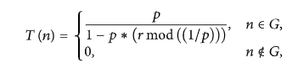

where  p is the percentage of CH in all nodes, r is the number of current election rounds,

(r mod(1/p)) is the number of nodes that have been selected in this round, and G is the set of nodes without CHs selected in this round. After the end of each CH selection round, each selected CH broadcasts its message of becoming a CH to other nodes. After receiving the broadcast message, other nodes choose to join a cluster according to the received signal strength and send their joining message to the selected CH [11]. Each CH creates and assigns a TDMA schedule between each member node after its member nodes are joined. Then, end the cluster establishment stage and start the data transmission stage. Node becomes cluster head for the current round if the number is less than threshold T (n). Once node is elected as a cluster head then it cannot become cluster head again until all the nodes of the cluster have become cluster head once. This is useful for balancing the energy consumption. In the second step, non-cluster head nodes receive the cluster head advertisement and then send join request to the cluster head informing that they are members of the cluster under that cluster head. All non-cluster head nodes save a lot of energy by turning off their transmitter all the time and turn it on only when they have something to transmit to the cluster head [2]. In third step, each of the chosen cluster head creates a transmission schedule for the member nodes of their cluster. TDMA schedule is created according to the number of nodes in the cluster. Each node then transmits its data in the allocated time schedule [3].

In the data transmission stage, each member node sends data to the CH within its allocated period, and the CH transmits data to the BS after data fusion. Therefore, CHs consume more energy than member nodes. LEACH ensures that all nodes are equally likely to act as CHs employing cycle circulation so that the nodes consume energy in a relatively balanced manner. However, factors such as residual energy of nodes and distance from the BS are still not considered. The randomness of the CH election may lead to the death of the CH far away from the BS due to the rapid exhaustion of energy, which affects the survival time of the whole network.

Low Energy Adaptive Clustering Hierarchy (LEACH) protocol is a TDMA based MAC protocol. The principal aim of this protocol is to improve the lifespan of wireless sensor networks by lowering the energy consumption required to create and maintain Cluster Heads.

LEACH is a hierarchical protocol in which most nodes transmit to cluster heads, and the cluster heads aggregate and compress the data and forward it to the base station (sink). Each node uses a [stochastic](https://en.wikipedia.org/wiki/Stochastic) algorithm at each round to determine whether it will become a cluster head in this round. LEACH assumes that each node has a radio powerful enough to directly reach the base station or the nearest cluster head, but that using this radio at full power all the time would waste energy.

Nodes that have been cluster heads cannot become cluster heads again for P rounds, where P is the desired percentage of cluster heads. Thereafter, each node has a 1/P probability of becoming a cluster head again. At the end of each round, each node that is not a cluster head selects the closest cluster head and joins that cluster. The cluster head then creates a schedule for each node in its cluster to transmit its data.

All nodes that are not cluster heads only communicate with the cluster head in a TDMA fashion, according to the schedule created by the cluster head. They do so using the minimum energy needed to reach the cluster head, and only need to keep their radios on during their time slot.

LEACH also uses [CDMA](https://en.wikipedia.org/wiki/Code_division_multiple_access) so that each cluster uses a different set of CDMA codes, to minimize interference between cluster.The operation of LEACH protocol consists of several rounds with two phases in each [3] [4]: Set-up Phase and Steady Phase.

In the Set-up phase the main goal is to make cluster and select the cluster head for each of the cluster by choosing the sensor node with maximum energy.Leach protocol is a typically representation of hierarchical routing protocol. It is self-adaptive and self-organized [2]. Leach protocol uses round as unit, each round is made up of cluster set-up stage and steady state storage for the purpose of reducing unnecessary energy costs. Phases of leach protocol are as follows: A. Set-up phase In the set-up phase, the main goal is to make cluster and select the cluster head for each of the cluster by choosing the sensor node with maximum energy [3]. Set-up phase has three fundamental steps: 1. Cluster head advertisement 2. Cluster set up 3. Creation of transmission schedule During the first step cluster head sends the advertisement packet to inform the cluster nodes that they have become a cluster head on the basis of the following formula:

Steady Phase which is comparatively longer in duration than the set-up deals mainly with the aggregation of data at the cluster heads and transmission of aggregated data to the Base station. In steady phase, cluster nodes send their data to the cluster head. The member sensors in each cluster can communicate only with the cluster head via a single hop transmission. Cluster head aggregates all the collected data and forwards data to the base station either directly or via other cluster head along with the static route defined in the source code. After predefined time, the network again goes back to the set-up phase. The LEACH protocol adopts the concept of clustering and periodic data collection, which can reduce the data transmission between the nodes and the BS. Therefore, this protocol can not only reduce the energy loss, but also can extend the network lifetime. In addition, the CH uses the method of data aggregation, which can reduce correlated data locally. This method can also optimize the amount of data in the network and reduce energy consumption. Moreover, the time division multiple access (TDMA) schedule used by LEACH allows the member nodes to go into sleep mode, and this mechanism holds back the collision between clusters and extends the sensors’ battery life

A cluster head in the LEACH protocol is not stabilized; LEACH is established over the round concept and each round includes two stages: a setup stage and a steady-state stage. The setup stage is separated into advertisement aspect and cluster setup aspect, while the steady stage includes the creation of schedule and transferring of data .The LEACH protocol suits WSNs under the following suppositions: & Every sensor node is static, exactly alike, and charged with the identical quantity of initial energy. & Every node consumes energy at the same degree and is capable to identify its remaining energy and controls power transferring and distance. & All nodes can directly connect to every other node, as well as the sink node. & The sink node is determined and in a distance from the wireless network. Thus, the energy consumed by the sink node is ignored. & All nodes have transferred data in each period. The data transmitted by sobering nodes are connected and can be combined.

However, the density of nodes is not considered in the traditional LEACH protocol when selecting the CH. The placement of nodes and the expected number of CHs per round are considered when assigning CHs. Therefore, this protocol cannot ensure the uniform distribution of the CHs Additionally; the LEACH protocol does not consider the residual energy of nodes and the average energy of all nodes when selecting the CH. This will lead to a node with a lower energy being chosen as the CH. Thus, this protocol leads to the quick exhaustion of the node energy. Finally, the CH communicates directly with the BS by adopting a single hop communication mode. Another version of the protocol is a LEACH-centralized protocol (LEACH-C), where the optimal number energy for the non-cluster head nodes to transmit their data to the cluster head, by minimizing the total sum of squared distance between all the non cluster head nodes and the closest cluster head. The resultant cluster head (CH) and their members will be broadcasted to the network. If the node’s own ID matches with cluster head ID , it elects himself as cluster head otherwise it will find out the TDMA slot to send the data to corresponding cluster head. The data transmission phase of LEACH-C is similar to the LEACH. The advantage of LEACH-C is that, it can equally distribute energy consumption between sensor nodes by positioning cluster heads into the center of cluster. But every sensor node, however, should be loaded with GPS receiver set and it does not guarantee the balance of energy consumption of whole sensor networks.of clusters K is determined based on a mathematical model. In contrast to LEACH concerning the CH selection and cluster formation, Base Station BS is responsible for these processes through the utilization of the simulated annealing optimization method, where at every round, the nodes that have more than the average energy will transmit their information to the BS.

LEACH–C is an improved version of LEACH, in which the cluster formation is done by the base station. At the beginning of every round all the nodes send their location and current energy to the base station. The base station calculates the average energy of the network and marks only those nodes which are having energy higher than the average energy, as eligible cluster head node. Now it applies simulated annealing [14] algorithm using candidate nodes to minimize the objective function. This algorithm attempts to minimize the amount of

The LEACH-C protocol [6] maintains such clustering hierarchy. In LEACHC, the clustering is triggered every T round second to select new cluster heads. Each node transmits to the closest cluster head so as to split the communication cost to the base station (which is much higher than the computation cost). Only the cluster head has to report to the base station and may expend a large amount of energy. In LEACH-C many nodes with higher energy cannot be selected as cluster head because of their below average energy which can actually still allow them to full-fill the task of being cluster heads.

**DISADVANTAGES:**

1. LEACH does not give any idea about the number of cluster heads in the network.

2. One of the biggest disadvantage of LEACH is that when due to any reason Cluster head dies, the cluster will become useless because the data gathered by the cluster nodes would never reach its destination i.e. Base Station.

3.Some cluster heads at the center of the cluster and some cluster heads may be in the edge of the cluster; this phenomenon can cause an increase in energy consumption and have great impact on the performance of the entire network.

4. CH selection is the most difficult part of dynamic clustering.

5.Inaccurate determination of the optimal number of clusters when using current mathematical models because the distance to the CH has not been estimated correctly.

6. In LEACH-C nodes, energy overhead persists, and the round trip is time-consuming throughout the CH selection process. The main disadvantage in existing method is the unbalanced energy consumption.

**CHAPTER-5**

**PROPOSED METHOD**

An improved energy-efficient clustering protocol (IEECP) to prolong the lifetime of the WSN-based IoT which consists of three parts: Firstly, a modified mathematical model is proposed based on the analysis of the energy consumption model for multi-hop communications and overlapping clusters in order to determine the optimal number of clusters. Secondly, a modified fuzzy C-means algorithm (M-FCM) is proposed in order to produce balanced cluster. Thirdly, a new algorithm is proposed known as CH selection and rotation algorithm (CHSRA) that integrates the back-off timer mechanism for

CH selection, with a new rotation mechanism for CH rotation among members of the cluster.

The main contribution by the proposed protocol is the prolonging of the WSN-based IoT lifetime that depends on the node's battery, which extensively increases the applications' range of the WSN-based IoT. This major contribution can be achieved through the following tasks:

1) Selecting the optimal number of clusters based on the modified mathematical model by considering the overlapping case among clusters and multi-hop communications,

2) Forming balanced clusters that reduce the cost in the intra-distance based on modified fuzzy C-means algorithm (M-FCM) that result from a combination of the FCM algorithm with a centralized mechanism,

3) Reducing the energy overhead that results from the CH selection process in each round by a new integration of the back-off timer mechanism for CH selection with rotation mechanism in one algorithm known as CH selection and rotation model (CHSRA),

4) Balancing the communication distance among the CHs in the network based on a new objective function for the back-off mechanism, and

5) Balancing the life of the selected CHs in the cluster based on a new dynamic threshold.

This section clarifies the proposed protocol which consists of three parts: determination of the optimal number of clusters based on a modified mathematical model, formation of balanced clusters based on a modified fuzzy C-means (M-FCM) and selection and rotation of the CH for clusters based on the CH selection-rotation algorithm (CHSRA).The clustering protocol should consider four aspects: 1) the optimal number of clusters, 2) the formation of balanced and static clusters, 3) the evenly distribution of the selected CHs in the monitoring area with low overhead in the selection process, and finally, 4) the CH rotation process that relies on a threshold value. However, these factors have not been addressed in depth by the existing studies, hence, affecting the clustering protocol performance.

A. DETERMINATION OF THE OPTIMAL NUMBER FOR CLUSTERS

The mathematical model is popularly used in the domain to ascertain the number of clusters. This method is less time-consuming in finding the number of clusters, where the number of clusters is defined prior to the execution of the deployment process for nodes. Accordingly, it is suitable for all types of applications, especially for real-time applications, hence, drawing many studies to utilize this method to determine the optimal number of clusters. This method is often executed by the BS.

The mathematical model relies on a disk model to represent the distance to the CH. The disk model [7] is often utilized for studying the WSN communication, taking into account the coverage area for the transmission and entailing a disk of the plane with radius R, as shown in Figure 5.1(a). This value represents the distance to the CH in the mathematical model. The estimated value of radius (R) has a significant effect on the final result of the number of clusters, as proven later in this paper. Although other studies consider the distance to CH is the same whether the clusters are overlapping or isolated, in reality, the value of the radius is greater in the overlapping clusters, as shown in Figure 5.2(b).We assume that N nodes are deployed randomly in a square sensing area (M2). If K clusters exist, then the means number of the total nodes for each cluster is N/K (one CH and N/K -1 of MNs). Every cluster head consumes an amount of energy when receiving data from MNs, aggregating them from MNs, and transmitting the aggregate data to the BS. As the BS is located outside the sensing area, the multi-hop communication is used to transmit the sensing data to BS.

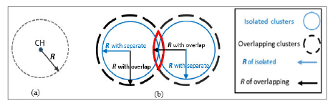

**Figure 5.1(a) disk model, and 5.2(b) difference in radius between**

**Overlapping clusters and separate clusters**

The optimum number of clusters can be obtained and given by:

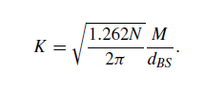

B. FORMATION OF BALANCED CLUSTERS

For the formation of balanced clusters, a modified fuzzy C-means algorithm (M-FCM) is proposed in this study by combining the FCM with a centralized mechanism. Before discussing the proposed algorithm to form balanced clusters, the conventional FCM algorithm is illustrated in the next section to provide a general idea.

1) FCM ALGORITHM OVERVIEW

The FCM algorithm has been widely used in the clustering processes for WSN cluster formation. This algorithm was originally presented by Dunn [31]. The goal of FCM is to form better clusters by reducing the summation of distances between the objects (N) and the cluster centers (C) by using the objective function. In WSN, the objects refer to nodes that are already distributed in the sensing area. The FCM objective function for organizing nodes into clusters in the WSN can be formulated as follows

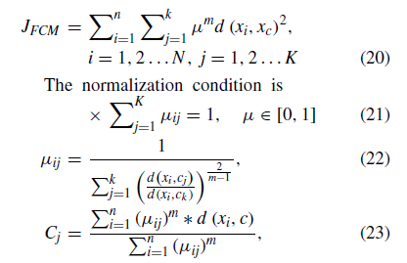

where K refers to the number of clusters, N refers to the number of nodes, µ refers to the membership of node (i) to cluster (j), Cj refers to cluster centroid; d refers to the distance between a node (i) and centroid (cj), commonly described by Euclidean distance; and m is the value of the fuzzifier that is chosen as a real number greater than 1 (m 2 [1;1)). m approaches to 1 clustering tend to become crisp (same as K-means algorithm) but when it reaches to the infinity, clustering becomes fuzzified (unreliable) [32]. Therefore, the value of fuzzifier is usually chosen as 2 in most of the applications [33], [34]. To terminate the algorithm, we use the condition where t is the current iteration, and  is a very small number close to zero (e.g., 0.001). On certain occasions, FCM produces unbalanced clusters because of the nature of the random deployment of sensor nodes in the monitoring area ,This situation leads to unbalanced energy consumption for nodes, which adversely affects the network lifetime . Some of the studies sought to overcome this problem by rearranging the degrees of belonging for nodes to produce balanced clusters.However, relying on the degrees of belonging is inefficient because of a normalization condition in the membership function, leading to an increase in the intra-distance for the clusters. Consequently, this condition increases the energy consumption of nodes .

To address this issue, a modified clustering algorithm has been proposed in this study to form balanced clusters with minimal intra-cluster distance by relying on the actual distance from centroids rather than the degrees of belonging for nodes.

2) MODIFIED FCM (M-FCM)

The proposed clustering algorithm is executed at the BS and consists of two phases: 1) initial cluster formation, which is based on the FCM, and 2) balanced cluster formation, which is based on the CM. In the initial cluster formation, the FCM is applied to form the clusters as shown in the algorithm, and then the process shifts to the second phase. The balanced cluster formation phase consists of two sub phases. The first sub phase consists of the following steps:

1) The cluster threshold (Thcluster ) is determined based on below equation

2) Clusters are sorted based on size. Minimum cluster size is compared with that of the Thcluster .

If the size is greater than the Thcluster , then the FCM creates balanced clusters. Otherwise, the process shifts to the second subphase.

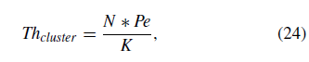

where Pe is the permittivity value equals to 0.85 [25], and K signifies the number of clusters.

In the second sub phase, CM considers the final centroids of the clusters that were produced from the previous phase (FCM phase) as initial points to form balanced clusters. Steps of the CM are as follows:

1. The distance between the initial points and nodes is determined.

2. Nodes are arranged based on their distance from the initial points.

3. The initial points select the nearest number of nodes that are equal to the threshold of the cluster value to join it.

4. The remaining nodes that are still non-jointed join the nearest initial point to construct the final clusters.

5. Each cluster determines the new centroid based on the means for node locations.

This procedure ensures that the minimum cluster size is equal to or greater than the threshold cluster range with lower intra- cluster distance.

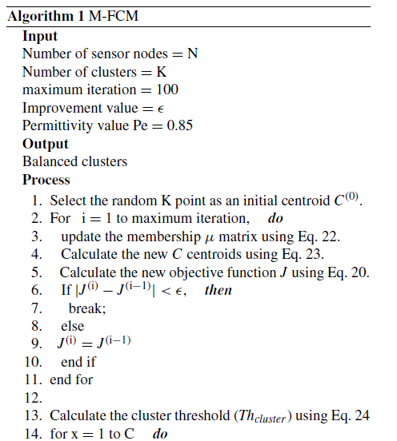

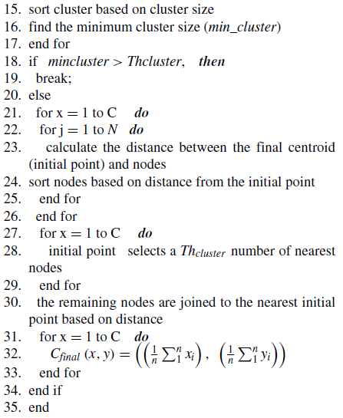

**CH SELECTION AND ROTATION ALGORITHM:**

The CH selection and rotation issues have gained a great interest in researchers. Furthermore, in this study, a new algorithm has been proposed by integrating the back-off timer mechanism for CH selection with a rotation mechanism called CHSRA. In this algorithm, the CH is selected accurately by using a new objective function. Furthermore, the CH function is rotated among the members of the cluster based on a new rotation mechanism, where it is executed without any contribution to the BS.

The goal of CHSRA is to reduce the overhead by selecting the CH within members of the cluster only. Furthermore, it balances the distance among CHs in adjacent clusters by adopting the routing information in the CH selection process that leads to balanced energy consumption for CHs. Besides,the CHSRA ensures the balance in energy consumption for the successive CHs of the cluster. The CHSRA comprises two phases:

1) CH selection phase implemented by the back-off timer mechanism, and

2) CH rotation phase implemented by the dynamic thresh- old mechanism.

**1) CH SELECTION PHASE**

The back-off timer mechanism is used to select the CH, which is a distributed mechanism. This mechanism is widely used in the literature because it reduces the overhead for nodes and has the least delay in the selection process. In this mechanism, each node in the cluster sets its timer. The node is set as either CH or CM according to its timer (Tb) and the advertisement (ADV) message is received before the timer terminates. If the node received the ADV message from another node in the cluster, then it will cancel its timer and become CM. However, if the timer expires and the node does not receive any message, it broadcasts the ADV message and becomes a CH [37]. The timer value is set based on an objective function (F) of the node, where the timer value is the converse of the objective function as follows

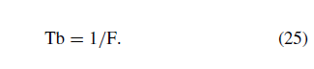

This is presumably, the first time that the back-off timer mechanism is applied to select the CH within members of the cluster. In the current study, this mechanism is applied to the CH selection in all network nodes, thus, increasing time and energy consumption. Another significant contribution con cerning the CH selection is to propose a new objective function for this mechanism that provides efficient distribution for the selected CHs in the network through selecting them in the optimal location. In this new objective function, the distance between a specific node to the forward CH (FCH) and the backward CH (BCH) is adopted along with the adjustment of coefficient for distances (ACD), in order to show the balance of distance between FCH and BCH and the residual energy of the node as the selection parameters for the CH selection process. This procedure ensures that the selected CH is in an optimal location according to the adjacent CHs of the other clusters. The proposed objective function relies on the a fore mentioned parameters rather than the residual energy of the node only [3]or the residual energy of the node and distance to the BS [24], as they do not guarantee the efficient distribution of the CHs in the network. Figure shows the effect of distances on the CH selection.

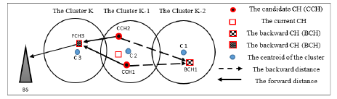

**Figure:** CH selection mechanism using backward and forward distance.

Consequently, each node in certain clusters computes the following parameters to define the objective function F, which are: residual energy Er to prevent selecting CH with low energy. The current value of energy in a node after receiving or transmitting routing packets is the residual energy



where Eini refers to the initial energy and Econ refers to the consumption energy of the node.

1) Euclidean distance from the nearest forward CH(dFCH ) to reduce the energy consumption for the candidate CH (j)

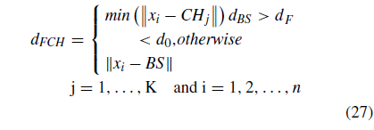

2) Euclidean distance from the nearest backward CH (dBCH ) to reduce energy consumption for backward CH (j-1)

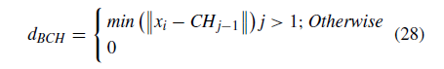

3) ACD for the node; this coefficient is responsible for showing the balance of distance between FCH and BCH.



According to these parameters, the objective function F for CH selection is



The selected CH based on this proposed algorithm over- comes the following two issues:

1) The energy overhead (additional energy cost) in the CH selection process is minimized by using the back-off time mechanism with members of the cluster rather than using all nodes in the network as in the current studies.

2) The CH is selected optimally because the required criteria for a balanced energy consumption in the selection are considered.

2) CH ROTATION PHASE

To solve the problem of unbalanced energy consumption for the successive CHs in the cluster, we set a dynamic threshold value for the CH rotation mechanism rather than the fixed value as in the other studies, where this value gradually increases with each process of the CH reselection. In this proposed mechanism, the energy consumed and the ratio from the initial energy (T) are used to estimate the threshold value. The first action taken by the selected CH directly after selection is calculating the value of its threshold for rotation (ETH) based on Eq. 31.

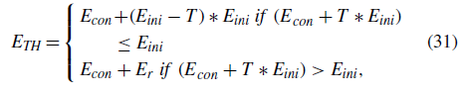

where Econ is the consumption energy of the node, Eini is the initial energy of the node, Er is the residual energy of the node, and T is a constant value of initial energy but may differ from one cluster to another subjects to the number of members in the cluster. The T value is estimated only once

for the cluster throughout the network lifetime. The T value can be calculated as follows

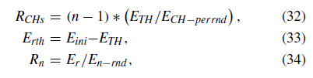

where RCHs refers to the rounds of all CHs in the cluster at the ETH , with Erth as the residual energy of the node at the ETH value, Rn represents the rounds of the member nodes in the cluster at the ETH , is the energy consumption per round for the CH, is the energy consumption per round for the nodes; and ETH is the threshold value within the range from 0.1 to 0.9 of the initial energy values for the node.



The appropriate value of T represents the intersection point of the curve of all CH rounds with the curve of members' rounds. At the end of each round, the CH in the cluster compares its energy with the threshold value that is computed based on Eq. 32. If the residual energy of the current CH is equal to or less than the threshold value, then the current CH changes. Otherwise, the CH continues its function. Finally, the preceding algorithms are combined in the IEECP framework that represents the main objective of this study, .For data transmission, members of the cluster directly transmit the sensing data to their selected CH. Then, the CH transmits this data to the BS by using a multi-hop manner. This manner is considered an advantageous option used to reduce energy consumption in case of relatively long-distance transmission [28]. In this manner, we adopt the same mechanism as portrayed in the [25]; the chosen CH checks if its transmission distance to BS is less than d0; it transmits the data directly to BS. Otherwise, it selects the nearest forward CH (towards BS) to reduce the energy consumption for CHs. Although this mechanism will lead to some delay in data

arrival at BS, it can bypass the long transmission distance for the selected CH, leading to energy saving for CHs.

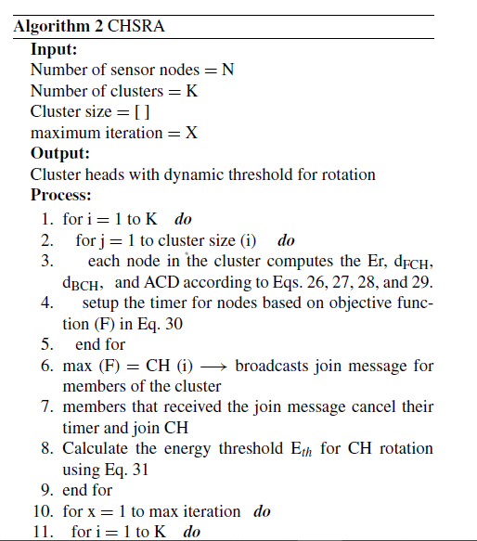

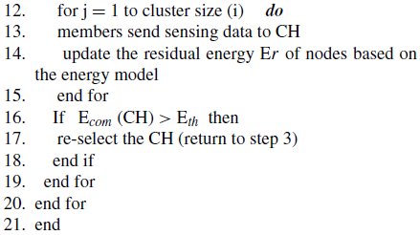

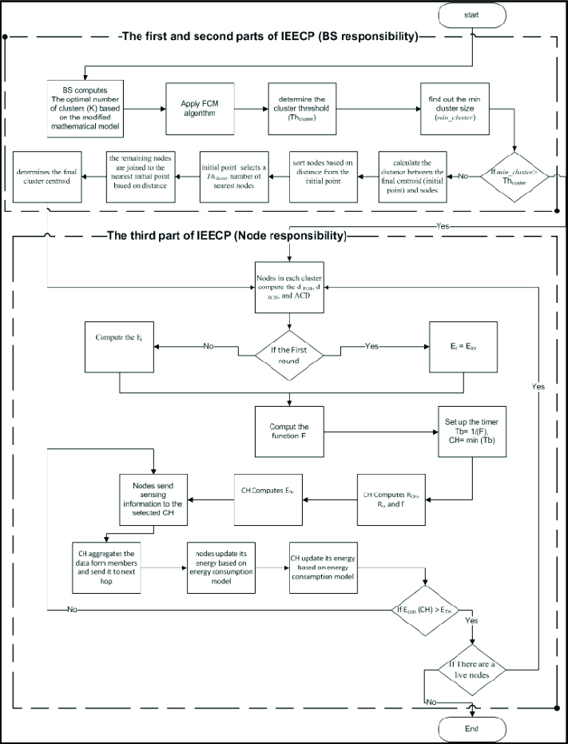

**FIGURE** : IEECP flowchart.

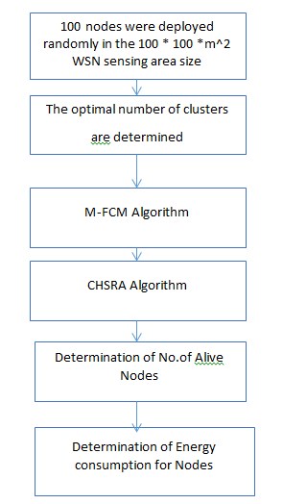

**Block diagram of proposed method**

the execution of the IEECP protocol processes occurs in two different places. The first place is theBS, where the number of clusters is computed initially based on the modified mathematical model, and then the balanced clusters are formed based on the M-FCM. The second place is the node, where the CH selection and rotation are processed based on the CHSRA algorithm. The determination of the number of clusters does not con- tribute to any time complexity, hence, it is deemed suitable for real-time applications. For the M-FCM, the time complexity is O((NK^2 x IFCM)+NK). The time complexity for FCM is O(NK^2 x IFCM) as reported by [20], where Nis the number of sensor nodes of the network, K is the required number of clusters, and IFCM is the number of FCM iterations. In M-FCM, the time complexity has been increased by NK rather than in FCM. However,

due to the one-time execution of this procedure through the BS prior to the network operation, there is no contribution to the time complexity related to M-FCM at the network operation. Moreover, since the BS does not have constraints related to the memory as found in the sensors, the space complexity of the M-FCM algorithm does not constitute any obstacle at the formation of clusters. Therefore, the parts of the IEECP protocol executed at the BS do not perform any time and space complexity with regard to the network operation. Since CHSRA is a distributed algorithm which is being applied within the cluster (it is not applied for the whole network), the member of the cluster updates its information

at each round. The CH re-selection phase occurs when the energy consumption of the current CH is more than the threshold; members of the cluster (n) need to update their information to select the next CH for the cluster by relying on CHs for other clusters (K-1). Thus, the analysis of the time complexity is based on the equations given in (30). Therefore,the time complexity is O (nxIround CK-1), where I_round is the number of rounds for the node until it dies. Consequently, the time complexity for the CHSRA is identical for the linear function, which is a small contribution for time complexity in terms of CH selection and rotation processes [38]. Further-more, the space complexity of the CHSRA is O (K^2+50), where it is an acceptable contribution of the space complexity for processes of the CH selection and rotation. As for the overload complexity, the nodes do not suffer from overhead during the formation of clusters due to the fact that this process occurs only once in the network, executed by the BS, getting the benefit of forming static clusters through a centralized approach. Likewise, for CHSRA, the overload for the CH selection is reduced to the maximum possible extent, as during the selection process only the node that will be the CH broadcasts ADV message to the rest of the cluster members for joining it. Similarly, for the re-selection process, only the CH broadcasts the message to the rest of the cluster members for the re-election. Therefore, the overhead complexity of the CHSRA is dependent upon the number of CH in the network, which equal to the number of clusters K. The overhead complexity of the CHSRA is constant and identical to an O(1) because K is a predefined fixed value. In other words, the overhead complexity is independent of the network size.

**CHAPTER-6**

**ADVANTAGES AND APPLICATIONS**

**Advantages:**

1.Proposed Protocol IEECP Prolongs the WSN-based IoT lifetime.

2. The proposed protocol reduces and balances the energy consumption of nodes by improving the clustering structure,

3. The evenly distribution of the selected CHs in the monitoring area with low overhead

in the selection process,

4.The optimal number of clusters are determined.

5. IEECP gives idea about the number of cluster heads in the network

6.It balances the distance among CHs in adjacent clusters by adopting the routing information in the CH selection process that leads to balanced energy consumption for CHs. The CH rotation process that relies on a threshold value is possible.

7.The CHSRA ensures the balance in energy consumption for the successive CHs of the cluster. So the Proposed Protocol IEECP gives balanced energy consumption.

**Applications:**

1.industrial control

2.environmental monitoring,

3. military surveillance,

4.intelligent transportation systems and medical field.

5.Furthermore, it can function independently in harsh or high-risk places where human presence is not possible

6.Disaster relief operations.

7.Biodiversity mapping

8.monitoring of temperature, pressure, and humidity

**CHAPTER-7**

**MATLAB**

**7.1 INTRODUCTION TO MATLAB**

**What Is MATLAB?**

MATLAB is an elite dialect for specialized registering. It incorporates calculation, representation, and programming in an easy to-utilize condition wherein issues and preparations are communicated in herbal numerical documentation. Run of the mill utilizes comprise

• Math and calculation

• Algorithm advancement

• Data obtaining

• Modeling, re-enactment, and prototyping

• Data examination, investigation, and representation

• Scientific and designing illustrations

• Application advancement, including graphical UI building

MATLAB is an intuitive framework whose important statistics aspect is an show off that does not require dimensioning. This allows you to tackle several specialized processing issues, particularly those with framework and vector info, in a small quantity of the time it'd take to compose a program in a scalar non intuitive dialect, as an instance, C or FORTRAN.

The call MATLAB stays for grid studies facility. MATLAB changed into first of all composed to present easy access to framework programming created by way of the LINPACK and EISPACK ventures. Today, MATLAB motors fuse the LAPACK and BLAS libraries, inserting the cutting side in programming for network calculation.

MATLAB has advanced over a time of years with contribution from several customers. In university situations, it's far the usual academic apparatus for early on and propelled guides in mathematics, designing, and science. In enterprise, MATLAB is the tool of choice for excessive-profitability studies, advancement, and exam.

MATLAB highlights a collection of more utility-specific arrangements known as tool booths. Important to most clients of MATLAB, device kits permit you to learnandapply particular innovation. Tool compartments are exhaustive accumulations of MATLAB capacities (M-records) that reach out the MATLAB condition to take care of precise training of problems. Territories in which tool stash are reachable include flag coping with, manipulate frameworks, neural structures, fluffy reason, wavelets, pastime, and severa others.

**The MATLAB System:**

The MATLAB system consists of five main parts.

**Development Environment:**

 This is the set of tools and centres that help you operate MATLAB features and files. Many of that gear are graphical person interfaces. It includes the MATLAB desktop and Command Window, a command history, an editor and debugger, and browsers for viewing assist, the workspace, files, and the hunt direction.

**The MATLAB Mathematical Function:**

This is a great collection of computational algorithms ranging from standard capabilities like sum, sine, cosine, and complex arithmetic, to extra sophisticated features like matrix inverse, matrix eigen values, Bessel functions, and speedy Fourier transforms.

**The MATLAB Language:**

This is a high-level matrix/array language with control flow statements, functions, data structures, input/output, and object-oriented programming features. It allows both "programming in the small" to rapidly create quick and dirty throw-away programs, and "programming in the large" to create complete large and complex application programs.

**Graphics:**

MATLAB has considerable centres for displaying vectors and matrices as graphs, as well as annotating and printing those graphs. It consists of high-stage functions for 2-dimensional and 3-dimensional records visualization, photograph processing, animation, and presentation graphics. It also consists of low-stage capabilities that will let you absolutely customise the appearance of graphics as well as to construct complete graphical person interfaces for your MATLAB programs.

**The MATLAB Application Program Interface (API):**

This is a library that allows you to put in writing C and Fortran applications that have interaction with MATLAB. It consists of facilities for calling workouts from MATLAB (dynamic linking), calling MATLAB as a computational engine, and for studying and writing MAT-documents.

**7.2 MATLAB WORKING ENVIRONMENT:**

## MATLAB DESKTOP:

Matlab Desktop is the principle Matlab application window. The desktop consists of five sub windows, the summon window, the workspace program, the existing catalog window, the order records window, and at the least one figure home windows, which can be proven simply while the consumer suggests a sensible.

The order window is the area the customer sorts MATLAB orders and expressions at the initiate (>>) and wherein the yield of these fees is shown. MATLAB characterizes the workspace because the association of factors that the customer makes in a work session. The workspace software demonstrates these elements and some statistics approximately them. Double tapping on a variable within the workspace application dispatches the Array Editor, which may be applied to get data and salary instances modify sure homes of the variable.

The present Directory tab over the workspace tab demonstrates the substance of the existing registry, whose way is seemed within the present index window. 1For case, within the windows running framework the manner may be as consistent with the subsequent: C:MATLABWork, demonstrating that registry "paintings" is a subdirectory of the primary catalog "MATLAB", which is delivered in pressure C. Tapping on the bolt inside the present index window demonstrates a rundown of as of past due utilized approaches. Tapping at the seize to one aspect of the window enables the client to exchange the existing catalog.

MATLAB utilizes an inquiry way to discover M-data and different MATLAB related documents, which might be sort out in catalogs within the PC file framework. Any file keep strolling in MATLAB must dwell inside the ebb and go with the flow registry or in an index that is on are trying to find manner. Of direction, the statistics supplied with MATLAB and math works device kits are included into the inquiry way. The least stressful method to look which indexes are at the inquiry manner. The handiest method to peer which catalogs are soon the quest way, or to encompass or regulate an inquiry manner, is to pick set manner from the File menu the computer, and after that utilization the set way exchange container. It is exquisite exercise to add any typically utilized catalogs to the pursuit way to hold a strategic distance from again and again having the exchange the existing index.

The Command History Window contains a record of the orders a client has entered in the charge window, including both present and past MATLAB sessions. Already entered MATLAB orders can be chosen and re-executed from the charge history window by right

tapping on a summon or arrangement of orders. This activity dispatches a menu from which to choose different choices notwithstanding executing the orders. This is helpful to choose different choices notwithstanding executing the summons. This is a valuable component while trying different things with different orders in a work session

**Using the MATLAB Editor to create M-Files:**

The MATLAB manager is both a word processor unique for making M-statistics and a graphical MATLAB debugger. The proofreader can display up in a window without everybody else, or it could be a sub window in the laptop. M-facts are intended by means of the expansion .M, as in pixelup.M. The MATLAB editorial manager window has various draw down menus for errands, for instance, sparing, seeing, and troubleshooting documents. Since it plays out a few basic checks and furthermore utilizes shading to separate between exclusive additives of code, this content device is suggested as the equipment of selection for composing and changing M-capacities. To open the proofreader, sort regulate at the incite opens the M-report filename.M in a supervisor window, organized for altering. As referred to before, the record has to be inside the momentum catalog, or in an index within the pursuit manner.

**Getting Help:**

The important technique to get help on line is to utilize the MATLAB assist application, opened as a exclusive window both via tapping at the query mark image at the computing device toolbar, or by using writing help program on the provoke within the order window. The help Browser is an internet application coordinated into the MATLAB computing device that shows a Hypertext Markup Language (HTML) statistics. The Help Browser contains of two sheets, the assistance pilot sheet, used to find out data, and the show sheet, used to look the statistics. Clear as crystal tabs aside from pilot sheet are applied to play out a pursuit. Second, within the motion pictures taken via transferring camera setup, the state of affairs becomes extra complex because the heritage may additionally exchange by using shifting shot, we cannot tune item motion exactly inside the sum of distinction map. Therefore, in this situation, the purpose is executed through reusing the previous seam and applying it to the cutting-edge body. In order to discover the seams, we use the preceding seam from previous body to look the modern-day seam in contemporary frame. our method is using a seam computed in frame1 (in crimson) to go looking a comparable seam in frame2. For the pixels close by the area of previous seam, we decide how a lot the selected pixel might vary from the pixel of preceding seam. We use difference of the 2 pixels as the degree of temporal coherence. If the distinction value of first seam pixel is over the threshold, we can keep to go looking the next seam pixel on three feasible pixels (in yellow, blue and brown) in subsequent row, until we discover 5 consecutive pixels that also exceed the threshold.

When we can't search the matching seam, we recalculate the energy for a new seam. We assume a seam 𝑆l-1 has been calculated inside the previous body, and a seam must be calculated for the contemporary frame. For preserving the temporal coherence, we want to make a new seam close to the previous seam with the identical index. We use the distinction among preceding seam and all pixels at the current body as the measure

Thus we upload temporal coherence price Tc(i,j) to the strength map earlier than calculating a seam 𝑆L. The price Tc is zero while the body pixels have the equal fee as previous seam pixels. Using our temporal coherence price, we will calculate the seam which has least electricity and is more close to the preceding seam in previous frame. Consequently, we will decrease the jittery artifacts inside the films.

**COMMUNICATION:**

Communications System Toolbox™ offers algorithms and gear for the layout, simulation, and analysis of communications systems. These capabilities are furnished as MATLAB ® features, MATLAB System gadgets™, and Simulink ® blocks. The machine toolbox includes algorithms for source coding, channel coding, interleaving, modulation, equalization, synchronization, and channel modeling. Tools are supplied for bit blunders charge evaluation, producing eye and constellation diagrams, and visualizing channel characteristics. The machine toolbox additionally provides adaptive algorithms that allow you to version dynamic communications structures that use OFDM, OFDMA, and MIMO techniques. Algorithms support fixed-point facts arithmetic and C or HDL code era.

**Key Features**

▪ Algorithms for designing the physical layer of communications systems, which includes supply coding, channel coding, interleaving, modulation, channel fashions, MIMO, equalization, and synchronization

▪ GPU-enabled System objects for computationally intensive algorithms together with Turbo, LDPC, and Viterbi decoders

▪ Interactive visualization equipment, consisting of eye diagrams, constellations, and channel scattering capabilities

▪ Graphical tool for evaluating the simulated bit mistakes rate of a machine with analytical outcomes

▪ Channel models, consisting of AWGN, Multipath Rayleigh Fading, Rician Fading, MIMO Multipath Fading, and

LTE MIMO Multipath Fading

▪ Basic RF impairments, along with nonlinearity, section noise, thermal noise, and section and frequency offsets

▪ Algorithms available as MATLAB features, MATLAB System objects, and Simulink blocks

▪ Support for fixed-point modeling and C and HDL code technology

**System Design, Characterization, and Visualization:**

The layout and simulation of a communications gadget requires analyzing its reaction to the noise and interference inherent in real-world environments, reading its behavior the usage of graphical and quantitative manner, and determining whether the resulting overall performance meets requirements of acceptability. Communications System Toolbox implements a selection of obligations for communications machine layout and simulation. Many of the functions, System objects™, and blocks inside the device toolbox perform computations associated with a specific thing of a communications gadget, consisting of a demodulator or equalizer. Other talents are designed for visualization or evaluation.

**System Characterization**

The system toolbox offers several standard methods for quantitatively characterizing system performance:

▪ Bit error rate (BER) computations

▪ Adjacent channel power ratio (ACPR) measurements

▪ Error vector magnitude (EVM) measurements

▪ Modulation error ratio (MER) measurements

Because BER computations are fundamental to the characterization of any communications system, the system toolbox provides the following tools and capabilities for configuring BER test scenarios and accelerating BER simulations:

**BER tool**— A graphical user interface that enables you to analyze BER performance of communications systems. You can analyze performance via a simulation-based, semi analytic, or theoretical approach.

**Error Rate Test Console** — A MATLAB object that runs simulations for communications systems to measure error rate performance. It supports user-specified test points and generation of parametric performance plots and surfaces. Accelerated performance can be realized when running on a multi core computing platform.

**Multi core and GPU acceleration** — A capability provided by Parallel Computing Toolbox™ that enables you to accelerate simulation performance using multi core and GPU hardware within your computer.

**Distributed computing and cloud computing support** — Capabilities provided by Parallel Computing Toolbox and MATLAB Distributed Computing Server™ that enable you to leverage the computing power of your server farms and the Amazon EC2 Web service. Performance Visualization. The system toolbox provides the following capabilities for visualizing system performance:

**Channel visualization tool** — For visualizing the characteristics of a fading channel

**Eye diagrams and signal constellation scatter plots** — for a qualitative, visual understanding of system behavior that enables you to make initial design decisions

**Signal trajectory plots** — for a continuous picture of the signal’s trajectory between decision points

**BER plots** — for visualizing quantitative BER performance of a design candidate, parameterized by metrics such as SNR and fixed-point word size

**Analog and Digital Modulation**

Analog and digital modulation strategies encode the facts circulation into a sign this is appropriate for transmission. Communications System Toolbox presents some of modulation and corresponding demodulation abilities. These talents are available as MATLAB features and gadgets, MATLAB System Modulation sorts provided by the toolbox are:

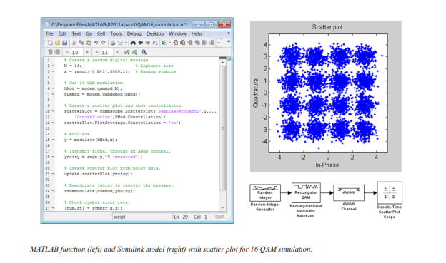**Source and Channel Coding**

Communications System Toolbox affords source and channel coding talents that can help you develop and compare communications architectures fast, enabling you to discover what-if eventualities and avoid the need to create coding competencies from scratch.

**Source Coding**

Source coding, also referred to as quantization or signal formatting, is a manner of processing facts a good way to lessen redundancy or prepare it for later processing. The system toolbox offers a diffusion of styles of algorithms for imposing source coding and interpreting, inclusive of:

▪ Quantizing

▪ Companding (*µ*-law and A-law)

▪ Differential pulse code modulation (DPCM)

▪ Huffman coding

▪ Arithmetic coding

**Channel Coding**

▪ orthogonal area-time block code (OSTBC) (encoder and decoder for MIMO channels)

▪ Turbo encoder and decoder examples

The gadget toolbox offers application functions for developing your personal channel coding. You can create generator polynomials and coefficients and syndrome deciphering tables, in addition to product parity-take a look at and generator matrices.

The system toolbox additionally presents block and convolutional interleaving and deinters leaving functions to reduce facts errors as a result of burst mistakes in a conversation machine:

**Block,** including General block interleaver, algebraic interleaver, helical scan interleaver, matrix interleaver, and random interleaver.

**Convolutional,** including General multiplexed interleaver, convolutional interleaver, and helical interleaver

**Channel Modeling and RF Impairments**

Channel Modeling

Communications System Toolbox provides algorithms and tools for modeling noise, fading, interference, and different distortions which might be commonly found in communications channels. The system toolbox supports the subsequent styles of channels:

▪ Additive white Gaussian noise (AWGN)

▪ Multiple-enter multiple-output (MIMO) fading

▪ Single-enter single-output (SISO), Rayleigh, and Rician fading

▪ Binary symmetric

A MATLAB channel object provides a concise, configurable implementation of channel models, enabling you to

specify parameters such as:

▪ Path delays

▪ Average path gains

▪ Maximum Doppler shifts

▪ K-Factor for Rician fading channels

▪ Doppler spectrum parameters

For MIMO systems, the MATLAB MIMO channel object expands these parameters to also include:

▪ Number of transmit antennas (up to 8)

▪ Number of receive antennas (up to 8)

▪ Transmit correlation matrix

▪ Receive correlation matrix

To combat the effects noise and channel corruption, the system toolbox provides block and convolutional coding and decoding techniques to implement error detection and correction. For simple error detection with no inherent correction, a cyclic redundancy check capability is also available. Channel coding capabilities provided by the system toolbox include:

▪ BCH encoder and decoder

▪ Reed-Solomon encoder and decoder

▪ LDPC encoder and decoder

▪ Convolutional encoder and Viterbi decoder

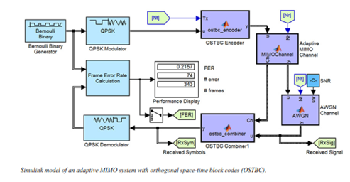

**RF Impairments**

To model the effects of a non-ideal RF front end, you can introduce the following impairments into your communications system, enabling you to explore and characterize performance with real-world effects:

▪ Memory less nonlinearity

▪ Phase and frequency offset

▪ Phase noise

▪ Thermal noise

You can include more complex RF impairments and RF circuit models in your design using SimRF™.

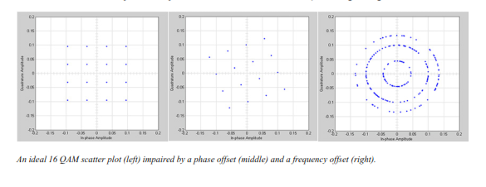

**Equalization and Synchronization**

Communications System Toolbox lets you discover equalization and synchronization strategies. These techniques are usually adaptive in nature and tough to design and symbolize. The machine toolbox affords algorithms and tools that will let you swiftly select the proper approach on your communications machine. Equalization To compare one-of-a-kind techniques to equalization, the device toolbox offers you with adaptive algorithms which include:

▪ LMS

▪ Normalized LMS

▪ Variable step LMS

▪ Signed LMS

▪ MLSE (Viterbi)

▪ RLS

▪ CMA

These adaptive equalizers are available as nonlinear decision feedback equalizer (DFE) implementations and as

Linear (symbol or fractionally spaced) equalizer implementations.

**Synchronization**

The device toolbox provides algorithms for each service segment synchronization and timing phase synchronization. For timing section synchronization, the machine toolbox presents a MATLAB Timing Phase Synchronizer object that offers the following implementation techniques:

▪ Early-late gate timing method

▪ Gardner’s method

▪ Fourth-order nonlinearity method

**Stream Processing in MATLAB and Simulink**

Most verbal exchange structures cope with streaming and frame-primarily based statistics using a aggregate of temporal processing and simultaneous multi frequency and multichannel processing. This form of streaming multidimensional processing can be visible in superior communication architectures consisting of OFDM and MIMO. Communications System Toolbox enables the simulation of advanced communications structures via helping move processing and frame-based simulation in MATLAB and Simulink. In MATLAB, circulate processing is enabled by way of System items™, which use MATLAB objects to symbolize time-based and facts-driven algorithms, sources, and sinks. System objects implicitly manipulate many information of flow processing, including information indexing, buffering, and management of set of rules state. You can mix System gadgets with fashionable MATLAB functions and operators. Most System items have a corresponding Simulink block with the identical abilities. Simulink handles circulation processing implicitly with the aid of coping with the float of information thru the blocks that make up a Simulink model. Simulink is an interactive graphical environment for modeling and simulating dynamic systems that uses hierarchical diagrams to symbolize a machine version. It includes a library of widespread-reason, predefined blocks to represent algorithms, resources, sinks, and device hierarchy.

**Implementing a Communications System**

Fixed-Point Modeling Many communications systems use hardware that requires a fixed-point representation of your design.

Communications System Toolbox supports fixed-point modeling in all relevant blocks and System objects™ with tools that help you configure fixed-point attributes.

Fixed-point support in the system toolbox includes:

▪ Word sizes from 1 to 128 bits

▪ Arbitrary binary-point placement

▪ Overflow handling methods (wrap or saturation)

▪ Rounding methods: ceiling, convergent, floor, nearest, round, simplest, and zero

Fixed-Point Tool in Simulink Fixed Point™ facilitates the conversion of floating-point data types to fixed point. For configuration of fixed-point properties, the tool tracks overflows and maxima and minima.

**Code Generation**

Once you've got advanced your set of rules or communications device, you can robotically generate C code from it for verification, rapid prototyping, and implementation. Most System gadgets, functions, and blocks in Communications System Toolbox can generate ANSI/ISO C code the use of MATLAB Coder™, Simulink Coder™, or Embedded Coder™. A subset of System gadgets and Simulink blocks also can generate HDL code. To leverage present highbrow belongings, you can choose optimizations for specific processor architectures and integrate legacy C code with the generated code.

You can also generate C code for both floating-point and fixed-point data types.

DSP Proto typing DSPs are used in communication system implementation for verification, rapid prototyping, or final hardware implementation. Using the processor-in-the-loop (PIL) simulation capability found in Embedded Coder, you can verify generated source code and compiled code by running your algorithm’s implementation code on a target processor. FPGA Prototyping

FPGAs are used in communication systems for implementing high-speed signal processing algorithms. Using the FPGA-in-the-loop (FIL) capability found in HDL Verifier™, you can test RTL code in real hardware for any existing HDL code, either manually written or automatically generated HDL code.

**CHAPTER -8**

**HARDWARE & SOFTWARE REQUIREMENTS:**

**Software:**

• Matlab R2018a.

**Hardware:**

**Operating Systems:**

• Windows 10

• Windows 7 Service Pack 1

• Windows Server 2019

• Windows Server 2016

**Processors:**

Minimum: Any Intel or AMD x86-64 processor

Recommended: Any Intel or AMD x86-64 processor with four logical cores and AVX2 instruction set support

**Disk:**

Minimum: 2.9 GB of HDD space for MATLAB only, 5-8 GB for a typical installation

Recommended: An SSD is recommended a full installation of all Math Works products may take up to 29 GB of disk space

**RAM:**

Minimum: 4 GB

Recommended: 8

**CHAPTER-12**

**REFERENCES**

[1]. J. Shen, A. Wang, C. Wang, P. C. K. Hung, and C.-F. Lai “An efficient centroid-based routing protocol for energy management in WSN-assisted IoT” IEEE Access, vol. 5, pp. 1846918479, 2017.

[2] V. Reddy and P. Gayathri, “ Integration of Internet of Things with wireless sensor network’’Int. J. Electr. Comput. Eng., vol. 9, no. 1, pp. 439444, 2019.

[3] H. P. Gupta, S. V. Rao, A. K. Yadav, and T. Dutta, “ Geographic routing in clustered wireless sensor networks among obstacles’’IEEE Sensors J., vol. 15, no. 5, pp. 29842992, May 2015.

[4] Q. Wang, S. Guo, J. Hu, and Y. Yang, “ Spectral partitioning and fuzzy C-means based clustering algorithm for big data wireless sensor networks’’ EURASIP J. Wireless Commun. Netw., vol. 2018, no. 1, pp. 111, Dec. 2018.

[5] S. Dehghani, B. Barekatain, and M. Pourzaferani,“ An enhanced energy- aware cluster-based routing algorithm in wireless sensor networks’’Wire-less Pers. Commun., vol. 98, no. 1, pp. 16051635, Jan. 2018.

[6]Di, Ma, and ErMengJoo. "A survey of machine learning in wireless sensor networks from networking and application perspectives." In Information, Communications & Signal Processing, 2007 6th International Conference on. IEEE, 2007.

[7] Akyildiz, Ian F., et al. "A survey on sensor networks." IEEE communications magazine 40.8 (2002): 102-114.

[8] Chan, Haowen, and Adrian Perrig. "ACE: An emergent algorithm for highly uniform cluster formation." European workshop on wireless sensor networks. Springer, Berlin, Heidelberg, 2004.

[9] Krishna, Prasad, et al. "A cluster-based approach for routing in dynamic networks." ACM SIGCOMM Computer Communication Review 27.2 (1997): 49-64.

[10] McDonald, A. Bruce, and Taieb F. Znati. "Design and performance of a distributed dynamic clustering algorithm for ad-hoc networks." Simulation Symposium, 2001. Proceedings. 34th Annual. IEEE, 2001.

[11] Tseng, Yu-Chee, et al. "The broadcast storm problem in a mobile ad hoc network." Wireless networks 8.2-3 (2002): 153-167.

[12] Estrin, Deborah, et al. "Next century challenges: Scalable coordination in sensor networks." Proceedings of the 5th annual ACM/IEEE international conference on Mobile computing and networking. ACM, 1999.

[13] Singh and Mandeep. "Extended stable election protocol with advance probability method in wireless sensor networks." (2014).

[14] Zheng, Jun, and Abbas Jamalipour, “”Wireless sensor networks: a networking perspective” in John Wiley & Sons, 2009.

[15] Wireless mesh sensor networks. wordpress.com/tag/wirelesssensor-networks-applications-and-challenges/.

[16] Kocakulak, Mustafa, and Ismail Butun. "An overview of Wireless Sensor Networks towards internet of things." Computing and Communication Workshop and Conference (CCWC), 2017 IEEE 7th Annual.

[17] Akyildiz, Ian F., Tommaso Melodia, and Kaushik R. Chowdury. "Wireless multimedia sensor networks: A survey." IEEE Wireless Communications 14.6 (2007).

[18] Wu, Chun-Hsien, and Yeh-Ching Chung. Heterogeneous wireless sensor network deployment and topology control based on irregular sensor model.” International Conference on Grid and Pervasive Computing. Springer, Berlin, Heidelberg, 2007.